Appendix
A1. Experimental set up of the single species tests
The impact of pyrimethanil on the growth of S. obliquus was tested with a standardized growth inhibition test according to OECD guideline 201 (OECD, 2002). Contrary to the guideline test tubes were used instead of Erlenmeyer flasks. The test substance pyrimethanil was diluted in algae growth medium with nominal concentrations of 0; 3.12; 6.25; 12.5; 20; and 25 mg L⁻¹. Each group consisted of five replicates. 15 mL of the pyrimethanil treated medium containing the appropriate concentration were filled into the test tubes and 5x10⁴ algal cells were initially pipetted into the samples. The test tubes were randomly allocated in climatic chambers under continuous ventilation and constant lighting (6,400 lux) at a temperature of 23°C. The relative humidity was 85% to prevent strong evaporation. After 24, 48 and 72 h, the chlorophyll α content was photometrically measured at 414 nm. For each replicate, eight aliquots were transferred to a 96 multiwell plate and the extinction was measured using a photometer (MultiskanAscent, Thermo Labsysteme).
The effect of pyrimethanil on the reproductive performance of Daphnia pulex was investigated following the OECD guideline 211 for Daphnia magna (OECD 2008). The nominal test concentrations were 0; 0.015; 0.03; 0.06; 0.125; 0.25; 0.5; 1.0 and 2.0 mg L⁻¹. Cetyl alcohol pellets were used to reduce surface tension where the juvenile daphnids could otherwise get caught and consequently perish. The cetyl alcohol did not influence the vitality of the daphnids.
Additionally, the chronic exposure of pyrimethanil towards Chaoborus flavicans was determined. Therefore the midges were priory cultured in natural pond water (sieved through a 63 µm, conductivity: 225-306 µS cm⁻¹, pH: 7.82-8.27) at 20°C ± 1°C and were fed once a week with 5 mL of a protozoan/rotifera suspension (mainly Oxytrichia, Taphrocampa and Trichocerca) and with 50 µL of a concentrated Scenedesmus subspicatus solution. The nominal concentrations within the experiment were 0; 0.125; 0.25; 0.5; 1.0; 2.0 and 4.0 mg L⁻¹. Every group consisted of 15 replicates each containing two L1-larvae. After test duration of three weeks, the mortality of larvae was recorded.

A2. Results of the single species tests
Figure A1 displays the increasing inhibition of the cell growth of S. obliquus as assessed after 72 h in response to the rising pyrimethanil concentration. Within the control group, the total cell amount is 14.9x10⁵ (± 2.84) cells. The growth is highly significant inhibited at a concentration of 25 mg L⁻¹ with 3.37x10⁵ (± 2.78) cells. The ecotoxicological specific values were calculated as following: the NOEC is 12.5 mg L⁻¹ and the LOEC is 20 mg L⁻¹. In addition, the calculated EC₁₀ value is 14.9 mg L⁻¹ with a confidence interval (CI) of 11.4-19.4 mg L⁻¹ and the EC₅₀ value is 20.9 with a CI of 19.2-22.7 mg L⁻¹.
The reproduction of D. pulex was inhibited in response of rising pyrimethanil concentration as indicated by the reduced number of neonates (Figure A1b). The mean number of neonates was 78.2 in the control group. First significant difference from the control level was observed at a concentration of 0.03 mg L⁻¹ (21.7 % inhibition). The LOEC was 0.03 mg L⁻¹, the NOEC 0.015 mg L⁻¹, the EC₁₀ 0.016 [CI 0.008-0.03] mg L⁻¹ and the EC₅₀ of 0.69 [CI 0.5-0.97] mg L⁻¹. The chronic exposure of C. flavicans towards pyrimethanil resulted in an EC₁₀ of 0.06 mg L⁻¹ [CI 0.02-0.234] mg L⁻¹ and an EC₅₀ of 1.78 [CI 1.06-2.98] mg L⁻¹.

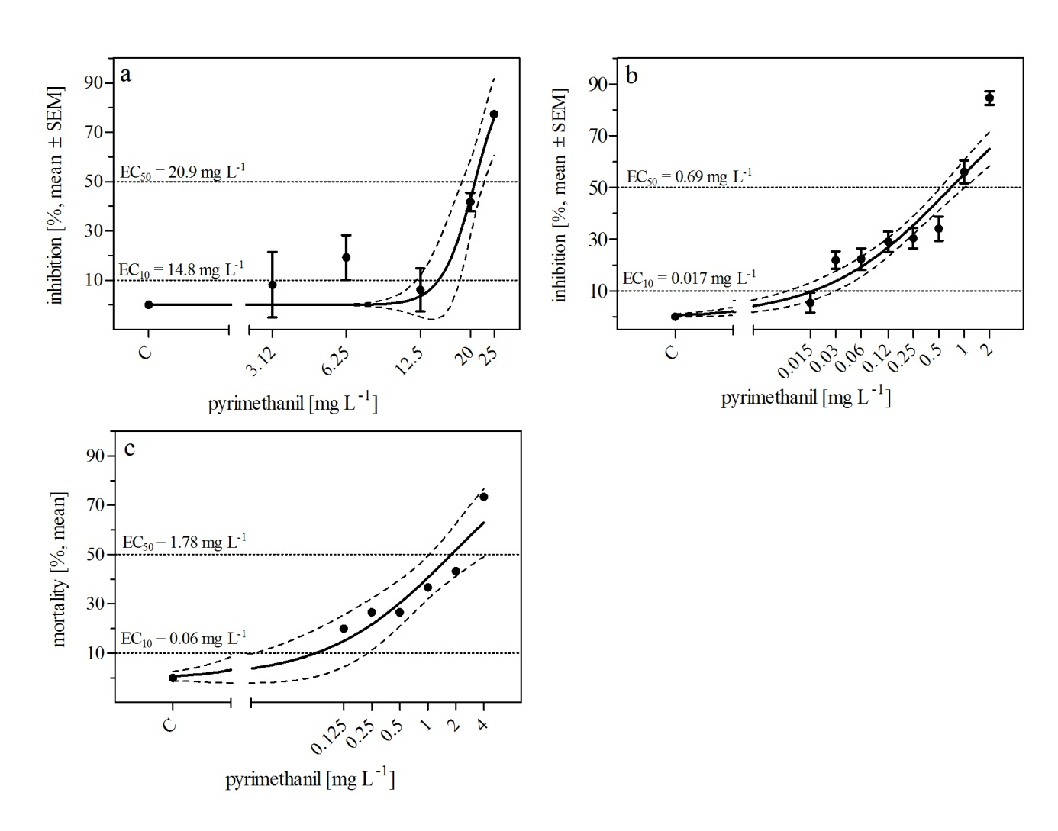
Figure A1: A) Scenedesmus obliquus: Inhibition of cell growth after 72 h of exposure towards 3.12-25 mg L⁻¹ of pyrimethanil and a control treatment [%; mean + SEM]. n = 5. B) Daphnia pulex: Inhibition of neonates [%, mean + SEM] after 21 d of exposure towards 0.015-2.0 mg L⁻¹ of pyrimethanil and a control treatment. n = 10. C) Mortality of Chaoborus flavicans larvae [%, mean] after 21 d of exposure towards 0.125-4.0 mg L⁻¹ of pyrimethanil and a control treatment.
n = 12. Dotted lines present the EC₁₀ and EC₅₀ values.

